EMAIL #1 – Illinois Rental Assistance Program:
Please use the image below and copy into your email.

IMAGE:
SUBJECT LINE: Rental Assistance Applications Available June 28th

EMAIL LANGUAGE:

If you are a resident of Will County who is behind on receiving or paying rent – you could be eligible to receive up to $25,000 in assistance. Visit www.ILRPP.IHDA.org to apply for rental assistance directly online from June 28 – July 18.

If you need help in applying visit www.willcountyillinois.org to learn more and find an agency near you that can help.

The landlord-led application period for the Illinois Rental Payment Program is now closed. ILRPP portal will reopen on at 9 a.m. on June 28, at which point tenants without a pending application for assistance can start an application.

After a tenant starts the application, a notification will be sent to their landlord to complete the application. IHDA will be reaching out to your landlord directly if they fail to timely submit the required information. If you are unsure whether your landlord will participate, you should still apply.

If you already applied for assistance, you can check on the status of your application at https://ilrpp.ihda.org/status using your application ID and your rental unit zip code.

EMAIL #2 – FREE HELP:
Please use the image below and copy into your email.
IMAGE:
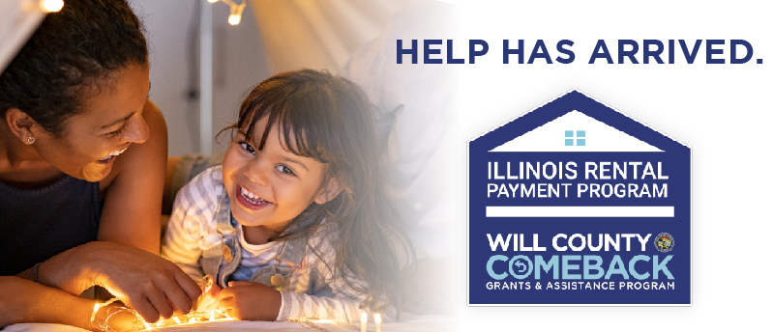
SUBJECT LINE: FREE LOCAL AGENCIES TO HELP APPLY FOR RENTAL ASSISTANCE
EMAIL LANGUAGE:
Applications for Rental Assistance are available online at www.ILRPP.IHDA.org from June 28 – July 18th where tenants can apply for up to $25,000 in relief.

If you are a resident of Will County that needs help in applying for rental assistance due to COVID-19 hardships, visit www.willcountyillinois.org and get connected with one of the local agencies below to help you with the application process:

Will County Center for Community Concerns
2455 Glenwood Ave, Joliet, IL - (815) 722-0722
www.wcccc.net

Spanish Community Center
309 N Eastern Avenue, Joliet, IL - (815) 727-3683
www.spanishcenter.org

South Suburban Housing Center
18220 Harwood Avenue, Suite 1, Homewood, IL - (708) 957-4674
www.southsuburbanhousingcenter.org

Holsten Human Capital Development
350 N Broadway St, Joliet, IL - (815) 770-5724
www.hhcd.org
EMAIL #3 – LOCAL AGENCY ASSISTANCE
Please use the image below and copy into your email.

IMAGE:
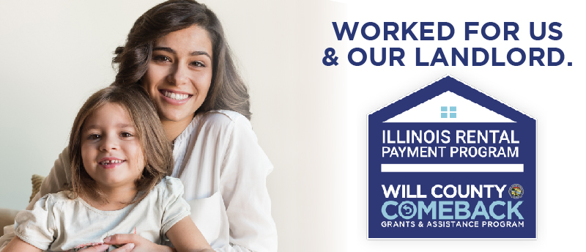

SUBJECT LINE: LEARN HOW TO APPLY FOR RENTAL ASSISTANCE

EMAIL LANGUAGE:
Applying for Rental Assistance is easy at www.ILRPP.IHDA.org from June 28 – July 18th where tenants can apply for up to $25,000 in relief.

If you need help on learning how to apply visit www.willcountyillinois.org and watch our instructional video or connect with one of our local agencies for help.

